**AIM**:

Basic configuration of Router using Cisco Packet Tracer.

**PROCEDURE**:

1. **Place the Router:**

* From the **Devices menu**, go to **Routers** and select a router model (e.g., **1841 Router**). Place it on the workspace.

1. **Add Network Devices (Optional):**

* Add switches and PCs if you want to connect multiple devices to the router, creating different networks or subnets.

1. **Connect Devices:**

* Use **Copper Straight-Through Cable** to connect the router to other devices.
* Connect **Router’s FastEthernet or GigabitEthernet ports** to the switches or directly to PCs, depending on the setup.

1. **Enter Router Configuration Mode:**

* Click on the router, then go to the **CLI (Command Line Interface)** tab.
* When prompted, type no if it asks if you want to enter the initial configuration dialog.

1. **Access the Router’s Global Configuration Mode:**

* Type enable to enter **privileged EXEC mode**.
* Type configure terminal to enter **global configuration mode**.

1. **Configure Router Interfaces:**

* Enter interface configuration mode for each interface you want to configure:
  + For **FastEthernet0/0**:

config# interface FastEthernet0/0

* + Set the IP address and subnet mask:

config# ip address 192.168.10.1 255.255.255.0

* + Turn on the interface:

config# no shutdown

* + Exit the interface configuration:

config# exit

* Repeat the process for **FastEthernet0/1** (or any other interface):

config# interface FastEthernet0/1

config# ip address 192.168.11.1 255.255.255.0

config# no shutdown

config# exit

1. **Configure Routing (Optional, if using multiple networks):**

* For **static routing**, type:

config# ip route 192.168.11.0 255.255.255.0 192.168.10.2

* This step is optional if you only need basic routing between directly connected networks.

1. **Save the Configuration:**

* To save the configuration, exit global configuration mode by typing exit until you return to the privileged EXEC mode.
* Type:

config# write memory

* Alternatively, use copy running-config startup-config to save the configuration to non-volatile memory.

1. **Test Connectivity:**

* Connect PCs to the router via switches or directly.
* Assign IP addresses and default gateways to each PC in their respective network.
* Use the **Ping Tool** to test communication between devices in different networks.

**DIAGRAM**:

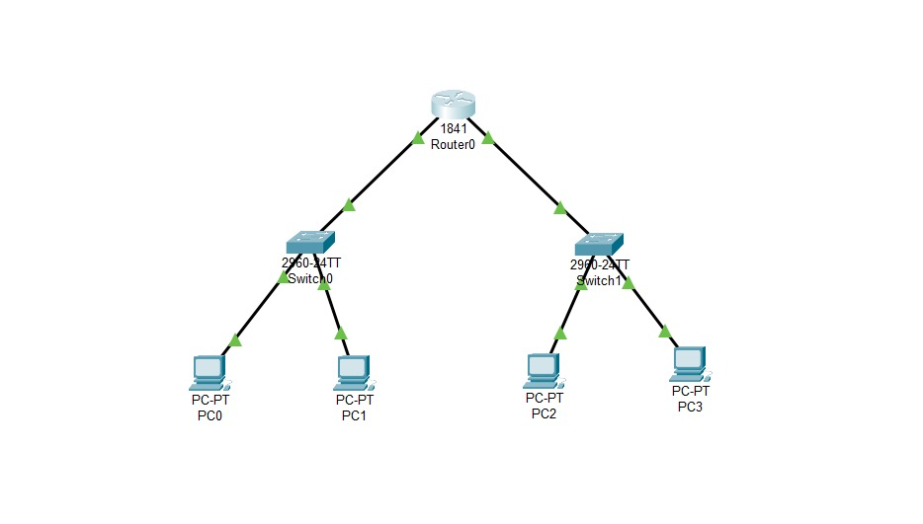

**RESULT**:

The basic router configuration is made using PCs, Switches and Router which connects all seamlessly.